**Accounts of ‘Not for Profit’ Concerns & Single Entry System – Set - 1**

**Q.1. Objective type questions:**

**(A) Fill in the blanks with appropriate alternative given in the brackets. [5]**

1. an asset 2. nominal account 3. revenue

4. surplus 5. subscription 6**.** trader

7. statement of affairs 8. deducted 9. Opening liabilities

10. subtraction

**(B) Write a word or a phrase which can substitute each of the following statements [5]**

1. Life membership fees 2. Balance sheet

3. Accrued income/outstanding income 4. Endowment fund

5. Deficit 6. Profit

7. Double Entry System 8. Sole trading concern & Partnership firm

9. Statement of profit or loss 10. Single Entry System

**(C) State with reasons whether the following statements are true or false [5]**

1. True 2. False 3. False 4. False 5. False

6. True 7. False 8. True 9. False 10. True

**Q.2. Working note on Depreciation:**

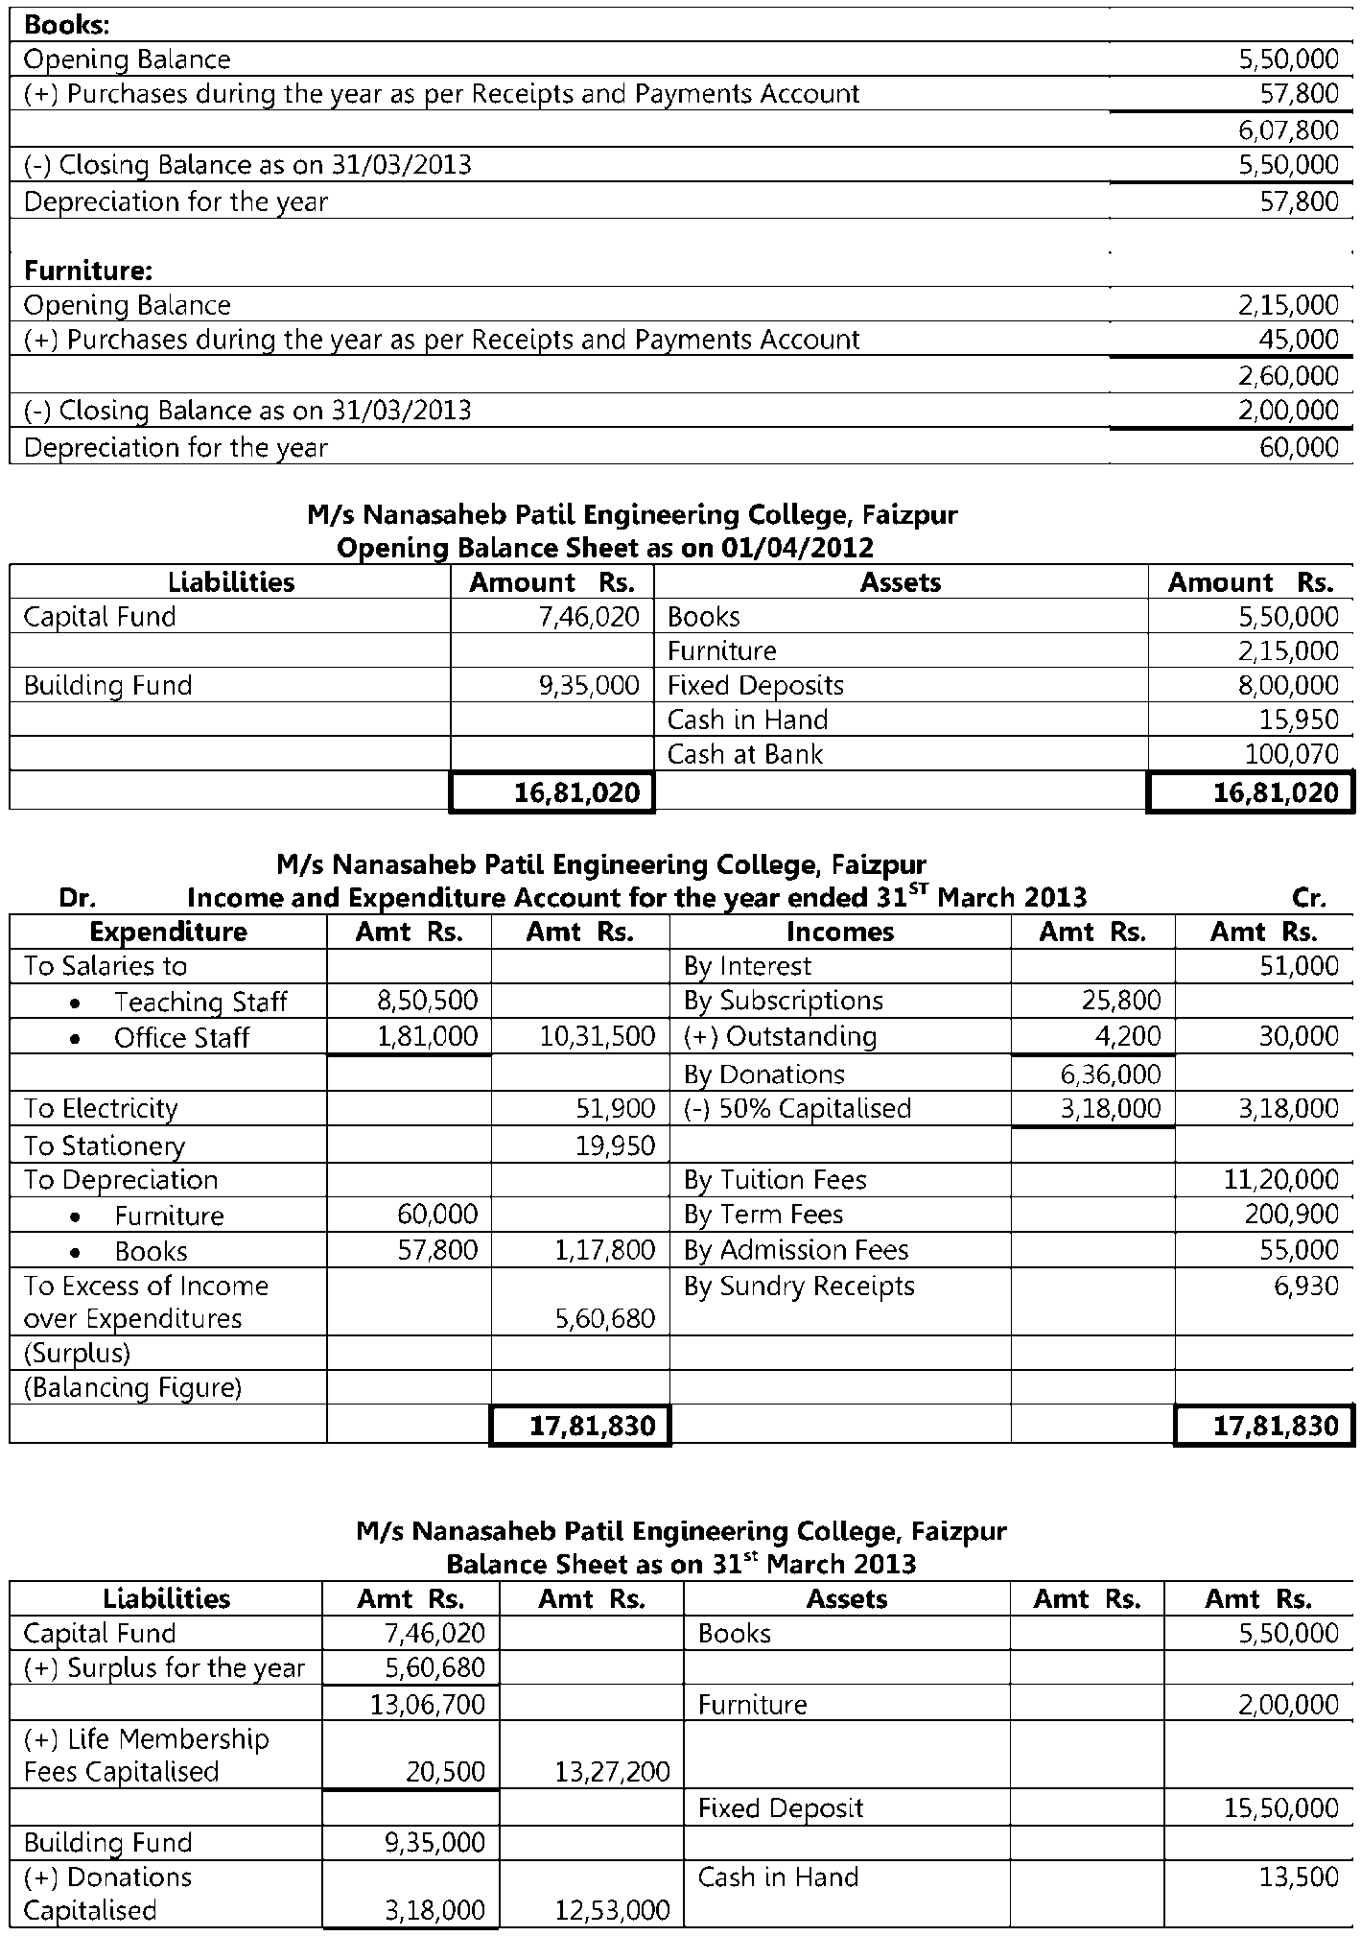



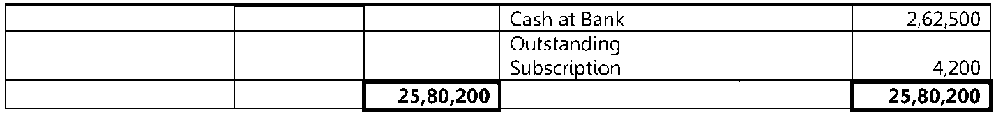

**Q.3.**





